

The Peples Republic of Bangladesh
Minstry of Health &Family Welfare (Health Services Division)
Health Economic Unit (HEU). Shasthyo Surokhsha Karmasuchi (SSK) Topkhana Road, Dhaka-1000

Replication of Chowgacha UHC-Jhenaidah District Hospital Model in Tangail District.

Visit Report: Chowgacha Upazilla Health Complex, Jashore.
Date of Visit: 05/05/22.AT 9-30AM.
Visitor: Dr.Md. Emdadul Haque, National Consultant (HEU) of MoHFW.

Admistrative discussion: Discussion with Dr. Lutfun Nahar, UH&FPO, RMO and other MOs about activites of the Model UHC, Chowgacha and its latest situation. The hospital is 50 bedded. The hospital stood 1st and awarded by ”Health Minster’s Award” for its best performance among all the Upazilla Health Complex of the country on 07-04 22.Therer are many positive sides in this hospital and a few weak points described below.
- Regarding attendance, accoding to the analysis of thumb impression for the month of March 2022, it was obserbed that with few exceptions most of the Consultants and MOs did not come and checked out in time.
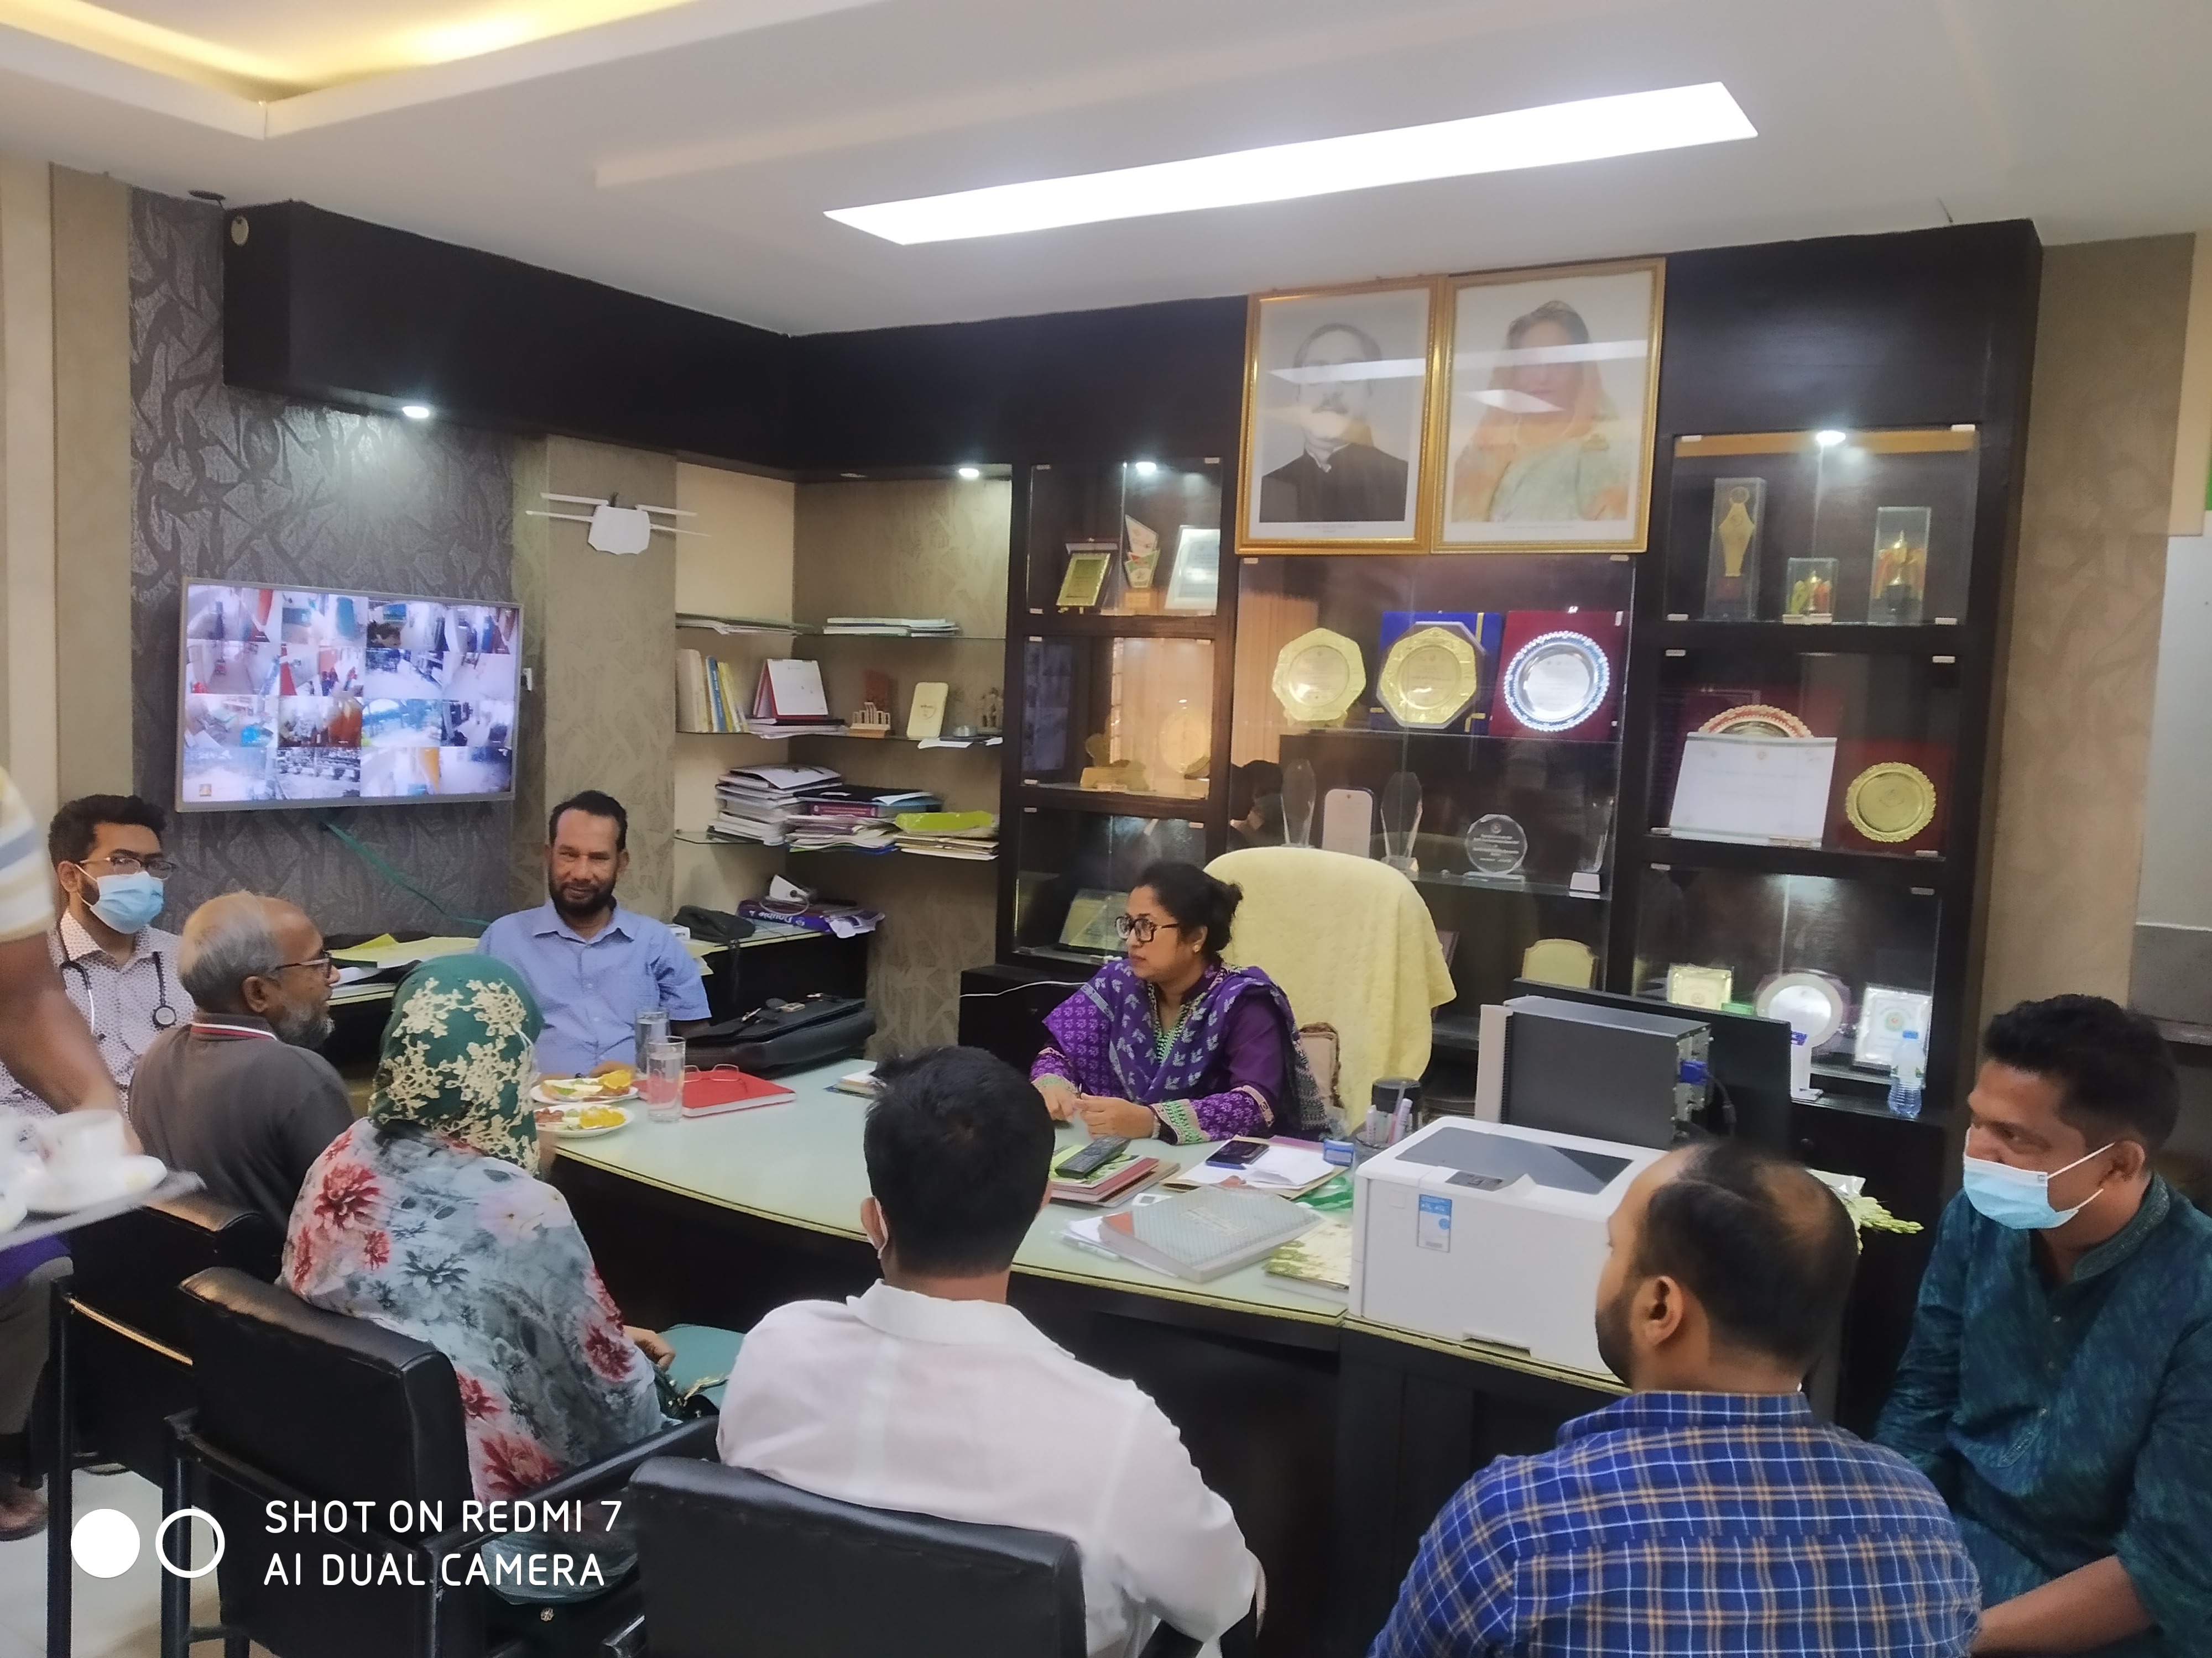
Meeting with UHFPO, RMO and Medical Officers at Chowgacha UHC on 5 May 2022

- Important Human Resource:
Sl No | Post | Allocated Post | Filled-up post | Vacant post | Comment
1 | RMO | 1 | 1 | 0 | In-charge
2 | Consultants | 10 | 3 (Anesth, Ortho, Gynae) | 7
3 | MO/Asst Surgeon (UHC + UnionH&FWC). | 20 (9+11) | 13 (5+8) | 7 (4+3)
4 | SACMO (Health Complex + Union (H & FWC) | 15 (2+13) | 11 | 4
5 | Head Asst, Accountant,  Casher | 3 | 0 | 3
6 | MLSS (UHC + U H&FWC) | 8 (4+4) | 2 (1+1) | 6 (3+3)
7 | Word Boy+Aya | 5 | 2 | 3
8 | Cleaner | 5 | 2 | 3
9 | MT(Lab) | 3 | 1 | 2
10 | Community supported manpower |  | 26
 | Total Human Resource | 209 | 137 | 72

- The performance of EOC service is musch better compare to many district hospitals of the country. But there is one gynoechologist in current charge and one anesthesiologist is working there. So, 24/7 EOC service is not going on.
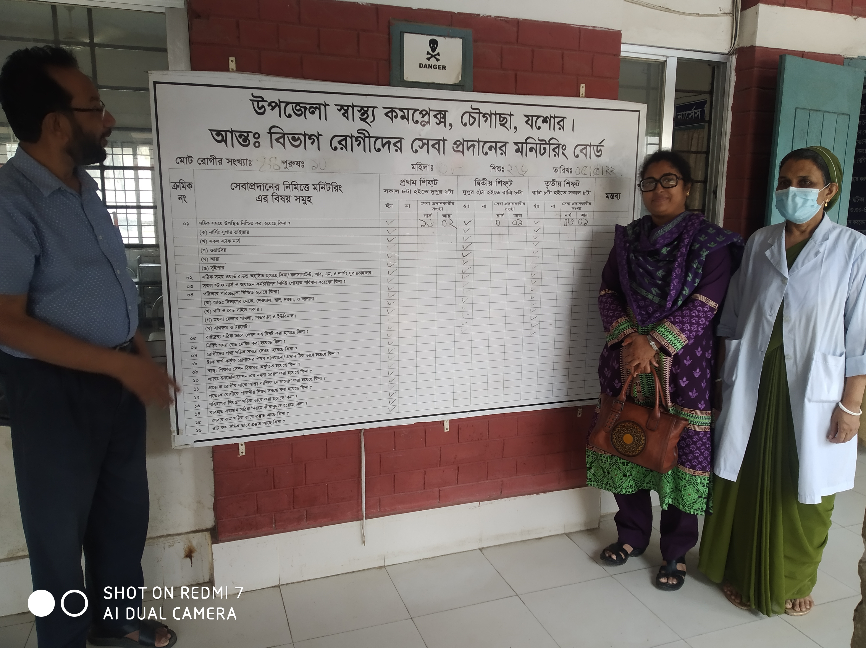
Monitoring system of the activites of nurses in indoor of Chowga UHC, UH&FPO Dr. Lutfun Nahar and Nursing Super Mrs.Jhumur Halder Visor were present on 05- 05-22.

- Visit to the emergency, out door & indoor: We visited the hospital campus with UH&FPO and RMO
- Campus is clean & beautiful. Cycle stand is close to the main gate.
- Writtings of many billboards are unclean, which hampers butification.
- Emergency managemet system is effective. Sterility is not maintaning properly.
- Lab service is not organized and not running effectively.
- Outdoor service is organized. Health education system is weak.
- Indoor: Effective labour word, A Cangaro care Corner is there. Information display system is weak. No Shoe-free enviornment in labour word. 24/7 EOC OT service is not available.
- EOC OT is not clean.
- Death recording system is weak, need special attention.

Conclutions: Maintenance of office time is essential. Fulfilment of vital post is important for sustainability and further development of Chowgacha Model. It is important to provided orientation on 7th 5year plan and the components Chowgacha Model for new officers and staffs.

